**Collaboration tools with**

**GitHub – How To**

*Many eyes make all bugs shallow*

*Linus Torvalds (The creator of Linux and GIT)*

*In that spirit the following is a quick overview and step by step guide on how to use the****GitHub****collaboration tools as it pertains to code reviews.*

**Log into USCC GitHub**

Bring up **GitHub** in a browser, and then go to the repository and directory you wish to place or update a file.

*In this example I'm in the RoamingReconciliation directory of the ISBillingandRevenueOperations repository.*

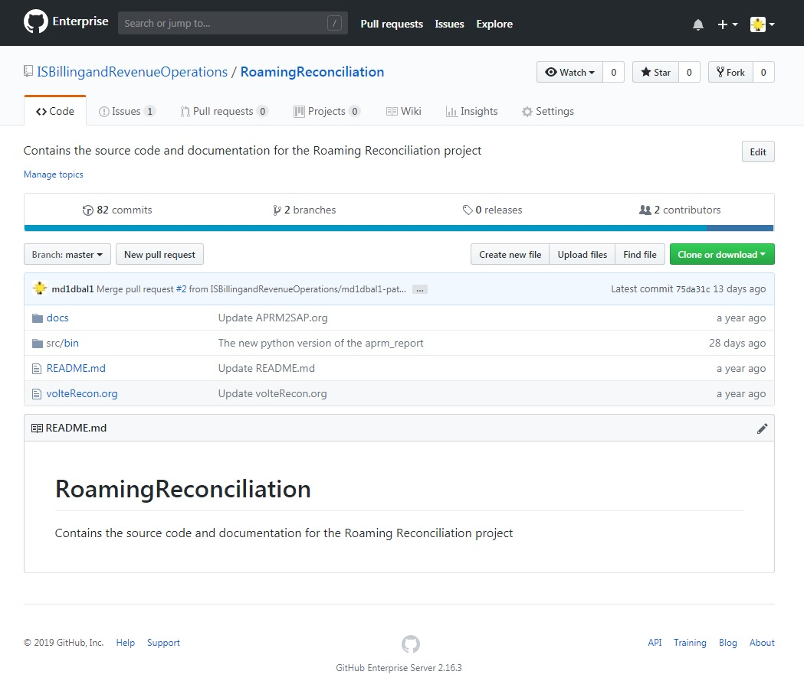

**Up load a file**

Underneath the blue line on the right hand side click on the **Upload files** icon where you'll be presented with the files screen. Upload your file, add your comments. At the bottom of the page click on the radio button with the words **Create a new branch for this commit and start a pull request.**

This automatically creates a new branch with your user-id as part of the patch name and the **Commit Change** button is now the **Propose Change.**

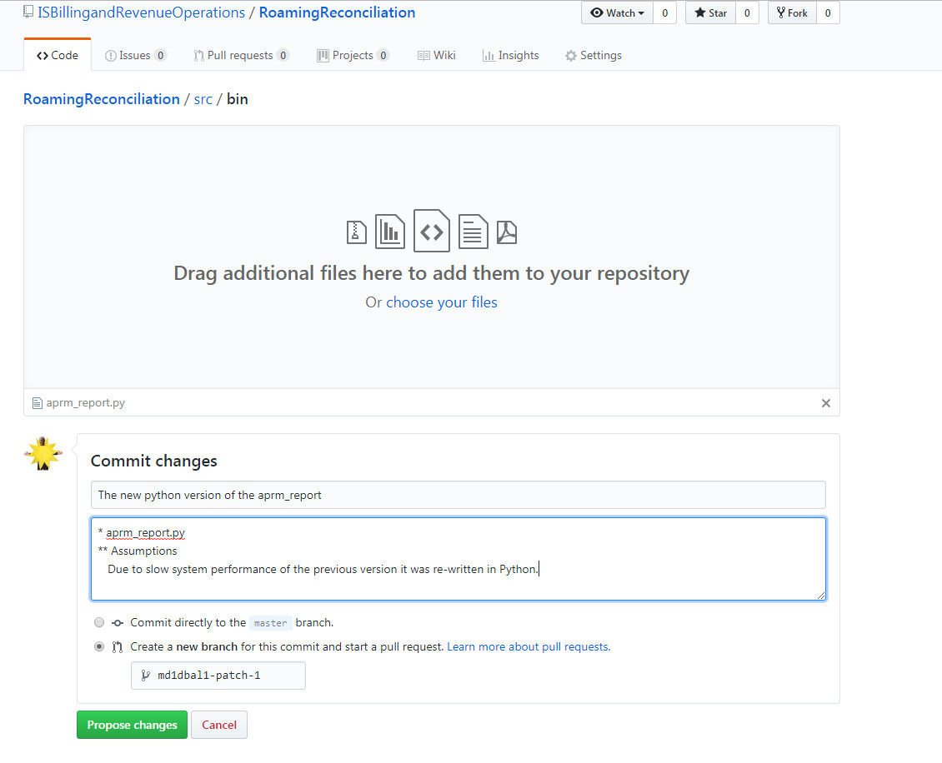

**Create Pull Request**

When you hit the **Propose Change** button you will enter into the **Open a pull request**. On this page you need do the following:

1. Give a Title
2. Write a comment *This would be a good place to put instructions to your reviewers*
3. Assign the Reviewers *Click the wheel on the reviewers section, found on the right hand side of the page, to pick your reviewers*
4. Assign the Assignee /Right below the reviewers tab. This should be **you**.

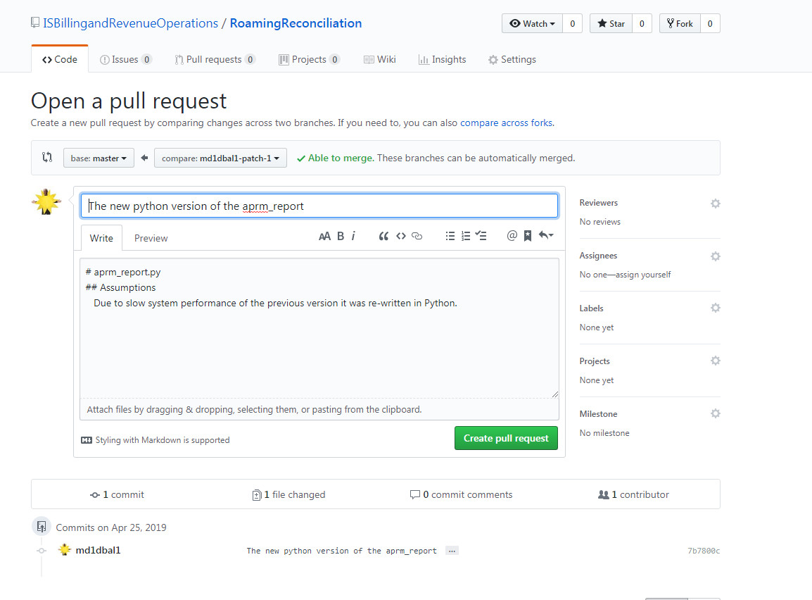

1. **Conversation View**

After you hit the **Create pull request** you will be thrown into the **Conversation** sub-tab of the **Pull requests** tab. It is from here that you can attach files, keep tabs and communicate with your reviewers. This is where you will spend the majority of your time until your reviewers approve the change.

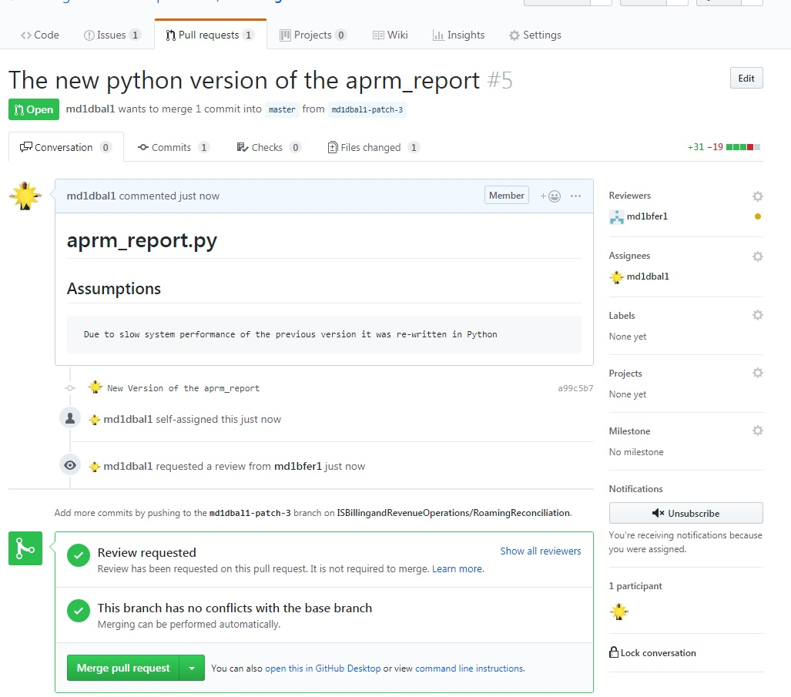

1. **Files changed**

You can reach this tab by clicking on the **Files changed** sub-tab under the **Pull requests** tab. If you are a **Reviewer** you will receive an email with a link to the tab. It is here that you review, make comments, approve or request changes to the change being reviewed.

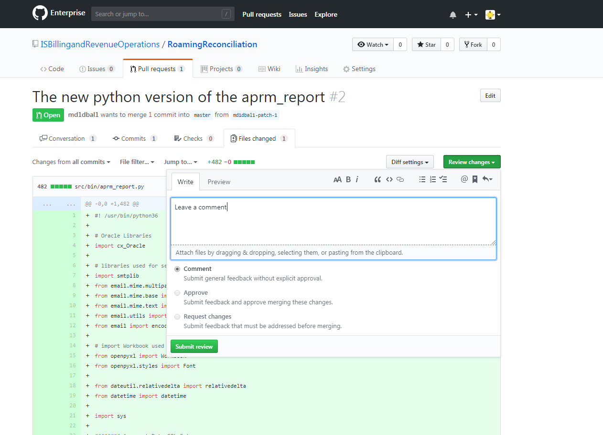

1. **Files changed (Continued)**

While you are reviewing you can also place a comment within the source itself. These comments as well as the overall reviewer comments will be displayed in the **Conversation View** described previously.

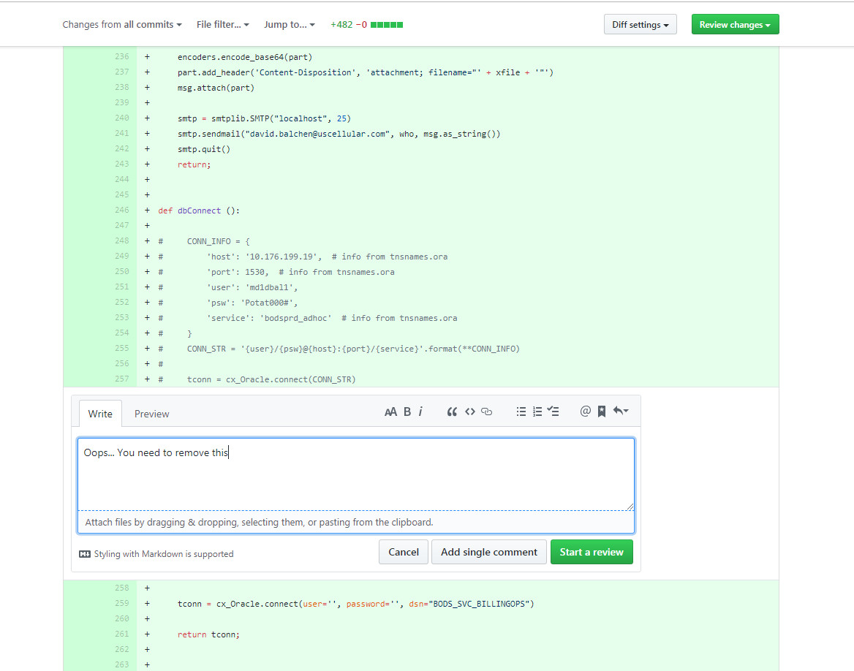

1. **Back to the conversation view**

After reviewers are done and they have approved the change you can now merge the change. After hitting the merge button you will presented with 3 options. At this point just use the first one, **Create a merge commit**, then your changes will be moved into the first branch.

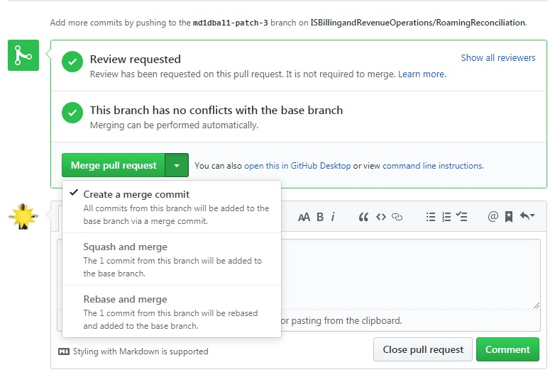

**Conclusion**

This document does not scratch the surface of what you can do with **GitHub**, it provides many features besides it collaboration tools. To learn more about the application, poke around and if you need more information consult the Internet.